1. Bekhti, R., Cardou, P., Duchaine, V. “Designing Multi-Axis Force–Torque Sensors by Minimizing the Amplitudes of Their Nonlinear Displacements”. Journal of Mechanical Design, Trans. ASME. MARCH 2016, Vol. 138

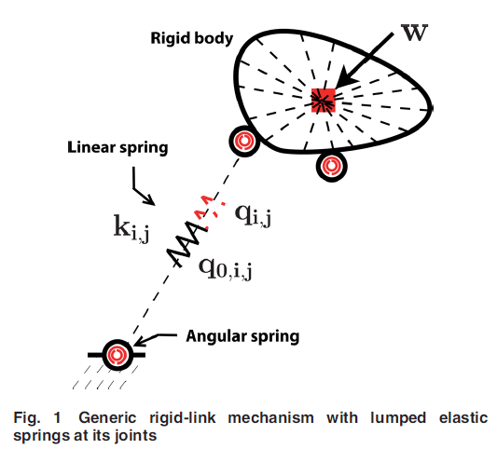This article presents a short description of the state of the art of compliant mechanism design with respect to multi-axis force-torque sensors. There has indeed been much research dedicated to optimizing mechanism design, and this paper concedes that the synthesis methods in current use are effective. However, the authors propose a novel means quantifying the design. Two new performance indexes which represents the linearity of the mechanism through its range are presented with their derivation and application examples.

The work is thorough and can be followed without much difficulty. All equations are shown with figures of the described mechanisms. I initially read a portion of their paper online without any of the figures which are reference. Figure 1 shown to the right was not in my original reading. I had no idea what the authors were talking about when they described “lumped elastic springs” and a “generic rigid-link mechanism”. The figure helped me realize the general nature of the description.

Another aspect of this paper that was well written is the argument for their method when other methods for compliant mechanism design exist. A majority of their 23 references are of existing methods and how they function. Each of the existing methods is catagorized for clear representation. However, the weakness of all other methods was clearly explained as well. The unique nature of the displacement analysis for determining error is that it had never been done before. Despite the efforts to systematically determine parameters which would characterize the error, the authors were the first to look at geometry changes.

The conclusion of their report is clear, with bullets for the key points. A quick review of the conclusion will help readers determine if the authors work is a potential solution. Despite the clarity of the paper, the presented analysis fails to show a practicle example in use. As they have described the presented analysis, the systems used are too simple to be useful. At least one detailed example of the technique being used in an applicable system would have benefited the paper very much.

1. Gonzalez, Carlos. “Choosing the Right Devices for IoT Connected Systems”. *Machine Design*. 8 January 2016. Web.

This article was not so much a guide for choosing the “right devices” as it was an advertisement for Siemens Industrial Controls. That is, I suppose, the difference in periodicals and technical papers. However, the author did describe the applicability of IoT devices in an industrial environment. The ability to monitor all critical aspects of a factory from any location with internet access is the true innovation. No more arriving to work on Monday morning to find a lab has flooded or a machine went down overnight. The intimate details of machines are now published on their own version of social media, the IoT cloud. This article was a disappointment, going over the basics of a few industrial IoT devices, but the IoT is still the amazing future of machines to me.